Efficacy of oral brush cytology in the evaluation of the oral premalignant and malignant lesions
M Babshet, K Nandimath, SK Pervatikar,¹ and VG Naikmasur
Department of Oral Medicine and Radiology, SDM College of Dental Sciences and Hospital, Dharwad, Karnataka, India
¹Department of General Pathology, SDM College of Dental Sciences and Hospital, Dharwad, Karnataka, India
Address for correspondence: Dr. Medha Babshet, Department of Oral Medicine and Radiology, SDM College of Dental Sciences and Hospital, Dharwad - 580 009, Karnataka, India. E-mail: medhababshet@hotmail.com
This is an open-access article distributed under the terms of the Creative Commons Attribution-Noncommercial-Share Alike 3.0 Unported, which permits unrestricted use, distribution, and reproduction in any medium, provided the original work is properly cited.
Abstract
Objective:
In the present study, oral brush cytology of premalignant and malignant lesions was performed using tooth brush. The cytopathological diagnosis of brush cytology was compared with that of punch biopsy. The reliability of oral brush cytology using tooth brush was assessed in terms of sensitivity and specificity.
Materials and Methods:
A total of 67 patients, 32 premalignant lesions and other 35 frank oral carcinomas, were included in the study. All patients underwent oral brush cytology using a toothbrush followed by punch biopsy. Sensitivity, specificity, positive and negative predictive values were calculated. Cytopathology and histopathology of premalignant and malignant lesions were compared using Mann-Whitney U test. Inter- and intra-examiner reliability was calculated using Rank-correlation coefficient.
Results:
Two in premalignant group and five in malignant group were marked insufficient. 18% of cases were false negatives. The sensitivity, specificity, positive predictive value and negative predictive value were 77%, 100%, 100% and 38%, respectively. Statistical analysis showed P>0.05, suggesting that there is no significant difference between histopathology and brush cytology in assessing both premalignant and malignant lesions. Inter- and intra-examiner reliability were 99.22% and 99.77%, respectively.
Conclusion:
Brush cytology using a tooth brush is reliable and can be easily performed with less cost and discomfort to the patient. It is useful in those situations when a patient refuses to have a biopsy performed or when medically compromised patients would be exposed to unnecessary surgical risks. It can be used for screening for suspicious oral lesions, and may have applications in resource-challenged areas.
Keywords: Brush cytology, cytopathology, dysplasia, oral squamous-cell carcinoma, potentially malignant disorders, screening
- Other Sections▼
  - Abstract
  - Introduction
  - Materials and Methods
  - Discussion
  - Conclusion
  - References
Introduction
Oral cancer is a global health problem with increasing incidence and mortality rates. Around 300,000 patients are annually estimated to have oral cancer worldwide. Although representing 2 to 4% of the malignancies in the West, oral cancer accounts for almost 40% of all cancers in the Indian subcontinent.[1] The following entities have been suggested as possible predisposing factors in the formation of head and neck cancer: Exposure to tobacco, radiation, malnutrition, alcohol consumption, genetic susceptibility, viruses, syphilis and traumatic irritation. The high incidence of oral cancer in India has emphasized the relationship between tobacco chewing, smoking habits and oral cancer.[2]
The concept of a two-step process of cancer development in the oral mucosa, i.e., the initial presence of a precursor (premalignant, precancerous) lesion subsequently developing into cancer, is well-established. A potentially malignant lesion is a morphologically altered tissue that has a greater than normal risk of malignant transformation. The presence of epithelial dysplasia is generally accepted as one of the most important predictors of malignant development in pre-malignant lesions. Several oral lesions like leukoplakia, erythroplakia, lichen planus and actinic keratosis are considered to be premalignant lesions for oral squamous-cell carcinoma, since an increased risk of malignant transformation is associated with them. These lesions are often subtle and asymptomatic, requiring a high index of suspicion on the part of clinician, especially if the risk factors such as tobacco use or alcohol abuse are present. In a recent study by Scheifele and Reichart,[3] based upon epidemiological data of European patients, it was concluded that the upper limit of the annual transformation rate of oral leukoplakia is unlikely to exceed 1%. On the basis of such data, it should be deduced that the first aim in the management of leukoplakia or any other potentially malignant lesion is the early diagnosis and prevention of malignant transformation.
When a suspicious oral lesion is encountered, the options for the clinician include an observation period of some defined time, vital staining like toluidine blue, methylene blue, etc., to assist in selection of most suspicious site for biopsy, various fluorescent and chemiluminescent aids to visualise the extent of the lesion, oral brush cytology and scalpel biopsy to evaluate the lesion. Vital stains are useful to choose biopsy sites, to mark lesion margins and to screen high-risk patients who have asymptomatic suspicious oral lesions.
Although surgical biopsy followed by histopathology is considered the gold standard for diagnosing the oral lesions, it may not be possible to carry out biopsy in every case as some of the patients may be medically compromised and a few patients with asymptomatic lesion may not give their consent for biopsy.
Cytological study of oral cells is a non-invasive technique that is well accepted by the patient, and is therefore an attractive option for the early diagnosis of potentially malignant disorders and malignant lesions of oral mucosa. Oral cells can be obtained by different techniques of scraping the surface of the mucosa, by rinsing the oral cavity or even by taking a sample of saliva from the patients. The use of cytology brush yields cells from deeper layers of the epithelium. Oral computer-assisted brush cytology (OralCDx) uses a brush specially designed to obtain a complete transepithelial specimen. OralCDx slides are stained in accordance with a modified Papanicolaou method. Stained slides then are scanned by the OralCDx computer system, which consists of a neural network-based image-processing system specifically designed to detect oral epithelial precancerous and cancerous cells. The OralCDx computer searches the brush cytology specimen for a combination of abnormal cellular morphology and abnormal keratinisation, which uniquely characterises dysplasia and carcinoma of the oral epithelium. The multicentre trial demonstrate the potential value of OralCDx as an adjunct to the oral cavity examination in identifying precancerous and cancerous lesions at early stages, when curative therapies are most effective.[4] However, its availability and cost makes its use in all settings difficult.
The use of brush cytology without computer-assisted analysis using toothbrush is less expensive and may have applications in resource-challenged areas and could be a risk-free method of evaluating oral lesions.[5] In this study, brush cytology of potentially malignant disorders and malignant lesions of oral mucosa was performed using a conventional tooth brush and subjected to cytopathological examination. Brush cytology results were compared with that of conventional punch biopsy results. The present study aimed at assessing the reliability of oral brush cytology in the detection of potentially malignant disorders and malignant lesions of the oral cavity in terms of sensitivity and specificity.
- Other Sections▼
  - Abstract
  - Introduction
  - Materials and Methods
  - Discussion
  - Conclusion
  - References
Materials and Methods
The subjects reporting to the outpatient department were selected for the study by employing convenience sampling method. Patients with suspicious oral potentially malignant and malignant lesions were selected irrespective of their age and gender. Oral potentially malignant disorders like leukoplakia, erythroplakia, palatal erythema, actinic cheilosis and erosive lichen planus and oral carcinoma were included in the study. However, oral submucous fibrosis, malignancy of central origin and medically compromised patients where incisional biopsy could not be performed for comparison were excluded.
The study sample comprised of total 67 patients, 32 being premalignant lesions and other 35 being frank oral carcinomas. A written informed consent was obtained from all the patients who were willing to participate in the study. A detailed history of the lesion in terms of duration, progress, associated symptoms and any treatment received for the lesion was obtained. An emphasis was given on the history of any adverse habit, if present, like tobacco or quid or gutkha chewing (gutkha is made up of betel nut, catechu, tobacco, lime, saffron and flavoring agents held in the mouth or chewed), smoking and alcohol consumption. All patients were subjected to a detailed intra-oral and extra-oral examination with thorough general medical examination. The characteristics of different lesions were evaluated in detail. In all cases, regional lymph nodes like submandibular, submental, buccal, pre-auricular, post-auricular, cervical and supraclavicular lymph nodes were examined. The number, site, size, tenderness, fixity and consistency of the lymph nodes involved were recorded. An oral brush cytology followed by punch biopsy was performed for every patient.
Oral brush cytology procedure
After rinsing the oral cavity thoroughly with water, the lesion was visualized under adequate illumination. A commercially available medium or hard nylon toothbrush was sterilised in 0.2% of chlorhexidine gluconate mouthwash for 24 hours and discarded after every use.[6] The tooth brush was used to obtain a complete transepithelial biopsy with minimal discomfort. Using moderate pressure, the brush was repeatedly brushed in one direction over the entire lesion many times until pinpoint bleeding was obtained, signalling entry into lamina propria and thus obtaining epithelial cells through the full thickness of the epithelium. The material from the brush was spread on the middle third of two clean, dried glass slides [Figure 1]. The smears were fixed immediately with 95% isopropyl alcohol for staining with hematoxylin and eosin (H and E) and the modified Papanicolaou method. The slides with at least 30 well-preserved cells (i.e., not obscured by blood or exudate or necrosis) from deep epithelial layers (intermediate or parabasal-basal) were considered adequate.
All specimens were examined manually independently by an experienced general cytopathologist in a double-blind manner. The cytological smears were interpreted based on the following parameters: Enlarged nuclei, variation in nuclear size and shape (pleomorphism), nuclear membrane irregularity, nucleocytoplasmic ratio, number of nuclei, binucleation, keratinisation, tadpole forms, hyperchromatism, chromatin pattern and distribution as well as discrepancy in nucleocytoplasmic maturation. The smears which showed dysplasia were graded as mild, moderate and severe. Cytology of homogenous leukoplakia demonstrates keratinized benign hypermature, polygonal cells or anucleated squamous cells. The severity of the component cells influences the placement of potentially malignant lesions into the categories of mild (early), moderate and severe (advanced, late and marked) dysplasia [Figure 2]. There is no single, measurable or constant criterion that one can depend on to separate unhesitatingly one category from other.[7] However, the following cellular feature variations are helpful in determining the stage of atypia with relative precision.
Feature variations which decrease with increased severity of dysplasia include
- Cellular cohesion
- Amount of cytoplasm
- Multinucleation
- Degree of maturation
- Normal flora
Feature variations which increase with increased severity of dysplasia include
- Mitosis
- Nuclear to cytoplasmic ratio
- Anisochromatism
- Nuclear membrane irregularities
Other feature variations with increased severity of dysplasia include
- Nuclear hypertrophy
- Anisokaryosis
- Hyperchromatism
- Nucleoli
Various cellular and nuclear changes are observed in squamous-cell carcinomas [Figure 3]. The malignant cells vary in size; most of them are about half of the size of corresponding normal superficial or intermediate squamous cells. Their shapes are very pleomorphic. They may be flat, round, polygonal, tadpole, spindle or irregular or in pearl formation, depending on the maturation of the tumor. The amount of cytoplasm and the intracytoplasmic keratin deposition depends on the maturation of the neoplasm. The nucleus-cytoplasmic ratio is increased. The malignant nuclei occupy about one-third of the volume of cells. The shape of the nucleus varies with that of the cell. The chromatin in the nucleus is irregularly distributed and clumped. Wrinkling and deep indentations are usually present in the nuclear membrane.[8] Those with malignancy were graded as well differentiated, moderately differentiated and poorly differentiated. Grading of squamous-cell carcinoma is based on the degree of differentiation and the amount of keratin present in the cytoplasm of the predominating tumor cells.
Grade I: A well-differentiated squamous-cell carcinoma exfoliating mainly keratinised malignant cells that stain deep orange with a Papanicolaou stain.
Grade II: At least 50% of the malignant cells are large, moderately differentiated, non-keratinising squamous cells.
Grade III: A poorly differentiated carcinoma exfoliating mainly non-keratinised cells that stain blue and resemble abnormal parabasal cells.[9]
The most common cytologic feature of verrucous carcinoma is abundant atypical parakeratotic or dyskeratotic cells with polygonal cytoplasm and distinct hyperchromatic nuclei [Figure 4]. Additionally, some cells can have a spindled appearance with elongated pyknotic nuclei, while other cell groups contain keratin pearls.[10]
Punch biopsy
The biopsy sections were obtained by punch biopsy and were interpreted by an oral pathologist and the grading of dysplasia and squamous-cell carcinoma was done based on the WHO criteria. On histopathological examination, the dysplasia was graded as mild, moderate, severe and carcinoma in-situ, while squamous-cell carcinoma was graded as well differentiated, moderately differentiated and poorly differentiated. The histopathological diagnosis was considered as gold standard and the cytopathological scores obtained from all the cases were compared with the respective histopathological scores.
Statistical analysis
Sensitivity and specificity were used for the statistical analysis of the samples. The true and false positives and negatives were based on the following:
- True positive: Samples that were positive on both histology and brush cytology.
- True negative: Samples that were negative on both histology and brush cytology.
- False positive: Samples those were negative on histology and positive on brush cytology.
- False negative: Samples those were positive on histology and negative on brush cytology.
Comparison of the cytopathological scores with histopathological scores of premalignant and malignant lesions was done using Mann-Whitney U test. Inter-examiner and intra-examiner reliability was calculated using Rank correlation coefficient.
Results
In the study, two out of 32 premalignant lesions and five out of 35 malignant lesions were found to be inadequate in cytopathology. Hence, the remaining 30 premalignant and 30 malignant cases were considered for the statistical evaluation. Table 1 shows the age, gender, affected site and adverse habits in patients of pre-malignant and malignant groups.
Severity of dysplastic lesions and grade of malignant lesions
Distribution of premalignant and malignant lesions based on histopathological grading of severity of dysplasia and squamous-cell carcinoma is shown in Table 2. Epithelial dysplasia was seen in 17 brush cytology smears and 13 showed anucleate squamous cells suggestive of hyperkeratinized epithelium among the 30 premalignant lesions. Among the malignant lesions, in 23 brush cytology smears, carcinomatous changes were detected. Five showed dysplasia and two showed anucleate squamous cells.
Comparison of histopathology and cytopathology
For the comparison of histopathology and brush cytology, a null hypothesis was considered that there is no difference between histopathology and brush cytology and level of significance of 5% was set. Application of Mann-Whitney U test showed P>0.05 suggesting there is no significant difference between histopathology and brush cytology in assessing both premalignant and malignant lesions [Table 3].
Sensitivity and specificity of oral brush cytology
Out of 60 cases including both premalignant and malignant lesions, 37 cases were found to be positive and seven to be negative on both histology and brush cytology. Eleven cases were found to be false negative on brush cytology, though not a single case of false positive was found. Sensitivity and specificity are shown in Table 4.
Reliability of brush cytology
Inter-examiner and intra-examiner reliability of brush cytology was calculated using Rank correlation coefficient. Both were highly significant with P<0.05 [Table 5].
- Other Sections▼
  - Abstract
  - Introduction
  - Materials and Methods
  - Discussion
  - Conclusion
  - References
Discussion
Incidence of oral cancers and oral premalignant lesions is very high in India as compared with western population. Though scalpel biopsy followed by histopathology is considered as gold standard in diagnosing these lesions, it may not be feasible to do scalpel biopsy in all suspected cases (the patient maybe medically compromised or may refuse to undergo scalpel biopsy). In such cases, brush cytology may offer an attractive alternative. This study was undertaken to compare the two techniques in terms of sensitivity, specificity and reliability.
In our study, males were predominantly affected with the large number of oral cancers developing in the fourth and fifth decades of life [Table 1]. In the study performed by Mehrotra et al.,[5] they found that 76% were males and 24% were females (M:F=3:1). The age of patients ranged from 10 to 80 years, with the majority of patients being in the 40 to 70 years age group. Cancer statistics state that oral cancer is common in males and commonly involves the buccal mucosa.[11] Age group of 45 to 65 years or older is at higher risk.[12]
Among the total 60 patients, 28.3% had smoking habit, 38.3% had the habit of tobacco chewing and 25% of the patients had a combination of quid, tobacco or gutkha chewing habits along with alcohol consumption. However, 5% of the patients had no adverse habits [Table 1]. In the study performed by Mehrotra et al.,[5] tobacco consumption was the most common with 54% patients having used it in one form or another, 35.4% gave a history of exposure to more than one carcinogen, while 5% patients consumed heavy amounts of alcohol.
In this study, buccal mucosa was the most frequently involved site (67%), followed by alveolus and gingiva (21%), lip (7%) and tongue (5%) [Table 1]. Mehrotra et al.,[5] in their study, found that buccal mucosa and tongue were the most frequently involved sites (35.7% and 21.4%, respectively).
Table 2 shows the distribution of premalignant and malignant lesions based on histopathological grading of severity of dysplasia and squamous-cell carcinoma. The comparison of histopathological and cytopathological reports showed that out of 23 histologically proven epithelial dysplasia samples, 17 brush cytology smears showed epithelial dysplasia. Out of 26 histologically proven cases of squamous-cell carcinoma and four cases of verrucous carcinoma, 23 brush cytology smears showed cells with carcinomatous changes. In our study, it was hypothesized that there is no difference between histopathology and brush cytology and level of significance of 5% was set. It was observed that the P value was more than 0.05 suggesting there is no significant difference between histopathology and cytopathology in both potentially malignant and malignant lesions [Table 3]. Hence, the hypothesis was accepted.
In our study, the sensitivity and specificity of brush cytology in detecting dysplasia and oral squamous cell carcinoma were 77% and 100%, respectively, and positive and negative predictive values were 100% and 38%, respectively [Table 4]. Moreover, when histopathology and brush cytology were compared, they showed good correlation with insignificant P values. Mehrotra et al.[5] used modified brush cytology without computer-assisted analysis in their study in the detection of oral lesions and found the sensitivity was 76.8% and specificity was 93.3%. In a study performed by Driemel et al.,[13] which evaluated the performance of oral brush biopsies using standard morphological analysis and HE staining for detecting oral squamous-cell carcinomas and their respective precursor lesions, a sensitivity and specificity of 79% and 93%, respectively, and positive predictive value of 88% which were comparable with our results but the negative predictive value was 88% was observed. In another study by Remmerbach et al.,[14] which reported the diagnostic accuracy of conventional oral brush cytology in suspicious oral lesions, sensitivity was 94.6%, specificity was 99.5%, positive predictive value was 98.1% and negative predictive value was 98.5%. In both the above studies the negative predictive values are much higher than the value obtained in our study. This could be due to the number of false negatives, i.e., 11 out of 60 patients accounting for 18% in our study.
The sensitivity of the oral brush cytology technique using oral CDx was found to be 71.4%, while the specificity of the test was 32%. The positive predictive value was 44.1%, while the negative predictive value was 60%.[15] Previous reports have shown four instances of histopathologically proven squamous-cell carcinoma with a previous negative brush cytology result, the mean delay between brush cytology and scalpel biopsy being 117 days.[16]
Brush cytology is an advantageous diagnostic procedure because it is non-invasive, relatively painless and inexpensive, and requires a minimum of technical skills. Despite the advantages of brush cytology, it has certain disadvantages like inadequate sampling and false-negative results. In the present study, commercially available tooth brush was used for scraping the mucosa. In this study, seven cases (10%) were found to be inadequate. In the study performed by Mehrotra et al.,[5] 15% of the cases were found to be inadequate. Inadequacy can result if the brush does not penetrate till the basement membrane. Therefore, it should be ascertained that brush has reached the basement membrane, by the appearance of pinpoint bleeding areas. The false-negative results and errors or pitfalls in cytopathological interpretation can be attributed to several factors like:
- Sampling error: Smear obtained from a non-representative site may not show abnormal diagnostic cells. Therefore, a direct sampling of the site of the lesion should be performed which generally produces the maximum number of diagnostic cells.
- Improper fixation: Air drying the smear or using a wrong fixative may produce artifacts and alterations in the cellular morphology.
- Cytopreparation: Staining and processing errors.
- Subjective errors by the inexperienced or careless cytopathologists. It is essential to screen the slide completely and mark the more characteristic cells. An effort should be made to identify every structure found in the smear and all cells should be analyzed.
- Lack of clinical information may also lead to improper interpretation of the cytological smear.[9]
Scheifele et al.[17] suggested that the main reason for the use of oral brush cytology is not to find a substitute for scalpel biopsy, but rather to take advantage of a first-level test that is able to identify dysplastic cells or molecular alterations which would be an indication for histological control, even in clinically apparent benign oral lesions. The importance of the brush cytology for evaluating benign-looking lesions has been emphasised in a multicentre study where nearly 5% of clinically benign-appearing mucosal lesions were sampled and later confirmed by scalpel biopsy to represent dysplastic epithelial changes or invasive cancer.[4,18]
Brush cytology is also useful in those situations when a patient refuses to have a biopsy performed or when medically compromised patients would be exposed to unnecessary surgical risks. In addition, anxious patients can be reassured quickly about the nature of oral mucosal changes, especially when a fear of cancer or a family history of cancer accounts for their apprehension.[19]
The reliability of the modified brush cytology technique using tooth brush was assessed by performing inter-examiner and intra-examiner observations [Table 5]. The rank correlation coefficient was found to be highly significant in both inter-examiner and intra-examiner observations suggesting that modified brush cytology is a reliable technique. Brush cytology has a low interobserver variability for the benign and malignant grades, suggesting that in the hands of an experienced cytopathologists, it can be relied on with confidence.[20]
- Other Sections▼
  - Abstract
  - Introduction
  - Materials and Methods
  - Discussion
  - Conclusion
  - References
Conclusion
Cytological study of oral cells is a non-invasive technique that is well accepted by the patient, and is therefore an attractive option for the early diagnosis of potentially malignant and malignant lesions of oral mucosa. Brush cytology is highly specific, however, relatively less sensitive, i.e., negative brush cytology does not rule out malignancy in all cases. Thus, it has a high positive predictive value and a low negative predictive value. There is no statistically significant difference between histopathological and cytopathological diagnosis in diagnosing dysplasia or carcinoma. Thus, brush cytology with a commercially available nylon tooth brush is an advantageous diagnostic procedure as it is non-invasive, relatively painless, inexpensive, less time consuming, reliable and requires minimum technical skill. It is useful in those situations when a patient refuses to have a biopsy performed or when medically compromised patients would be exposed to unnecessary surgical risks. Brush cytology is useful in screening of suspicious oral lesions.
Footnotes
Source of Support: Nil
Conflict of Interest: None declared.
- Other Sections▼
  - Abstract
  - Introduction
  - Materials and Methods
  - Discussion
  - Conclusion
  - References
References
1. Mehrotra R, Singh M, Kumar D, Pande AN, Gupta RK, Sinha US. Age specific incidence rate and pathological spectrum or oral cancer in Allahabad. Ind J Med Sci. 2003;57:400–4.
2. Gupta PC, Nandakumar A. Oral cancer scene in India. Oral Diseases. 1999;5:1–2. [PubMed: 10218033]
3. Scheifele C, Reichart PA. Is there a natural limit of the transformation rate of oral leukoplakia? Oral Oncol. 2003;39:470–5. [PubMed: 12747971]
4. Sciubba JJ. Improving detection of precancerous and cancerous oral lesions: Computer-assisted analysis of the oral brush biopsy. U.S. Collaborative OralCDx Study Group. J Am Dent Assoc. 1999;130:1445–57. [PubMed: 10570588]
5. Mehrotra R, Singh MK, Pandya S, Singh M. The use of an oral brush biopsy without computer-assisted analysis in the evaluation of oral lesions: a study of 94 patients. Oral Surg Oral Med Oral Pathol Oral Radiol Endod. 2008;106:246–53. [PubMed: 18644521]
6. Bhat SS, Hegde KS, George RM. Microbial contamination of tooth brushes and their decontamination. J Indian Soc Pedod Prev Dent. 2003;21:108–12. [PubMed: 14703217]
7. Vooijs GP, Elias A, van der Graaf Y, Poelen-van de Berg M. The influence of sample takers on the cellular composition of cervical smears. Acta Cytol. 1986;30:251–7. [PubMed: 3459325]
8. Nasiell K, Nasiell M, Vaklavinkova V. Behavior of moderate cervical dysplasia during long-term follow up. Obstet Gynecol. 1983;61:609–14. [PubMed: 6835614]
9. Zuher MN. Cytopathology. 4th ed. New York: Little, Brown and Company; 1996. pp. 127–47.
10. Chute DJ, Stelow EB. Cytology of head and neck squamous cell carcinoma variants. Diagn Cytopathol. 2009;38:65–80. [PubMed: 19582815]
11. Wingo PA, Tong T, Bolden S. Cancer Statistics, 1995. CA Cancer J Clin. 1995;45:8–30. [PubMed: 7528632]
12. Population Estimates Program, Population Division, U.S. Census Bureau. Resident population estimates of the United States by age and sex: April 1, 1990 to November 1, 1999. [Last accessed Feb 28]. Available from: http://www.census.gov/population/estimates/nation/intfile2-1.txt .
13. Driemel O, Kunkel M, Hullmann M, Kleinsasser N, Staudenmaier R, Muller-Richter U, et al. Performance of conventional oral brush biopsies. HNO. 2008;56:205–10. [PubMed: 18214406]
14. Remmerbach TW, Weidenbach H, Pomjanski N, Knops K, Mathes S, Hemprich A, et al. Cytologic and DNA-cytometric early diagnosis of oral cancer. Anal Cell Pathol. 2001;22:211–21. [PubMed: 11564897]
15. Poate TW, Buchanan JA, Hodgson TA, Speight PM, Barrett AW, Moles DR, et al. An audit of the efficacy of the oral brush biopsy technique in a specialist Oral Medicine unit. Oral Oncol. 2004;40:829–34. [PubMed: 15288839]
16. Potter TJ, Summerlin DJ, Campbell JH. Oral malignancies associated with negative transepithelial brush biopsy. J oral Maxillofac Surg. 2003;61:674–77. [PubMed: 12796875]
17. Scheifele C, Schmidt-Westhausen AM, Dietrich T, Reichart A. The sensitivity and specificity of the OralCDx technique: evaluation of 103 cases. Oral Oncol. 2004;40:824–8. [PubMed: 15288838]
18. Felefli S, Flaitz CM. The oral brush cytology: It's easy as 1, 2, 3. Texas Dent J. 2000;117:20–4. [PubMed: 11857852]
19. Jones AC, Pink FE, Sandow PL, Stewart CM, Migliorati CA, Baughman RA, et al. The cytobrush plus cell collector in oral cytology. Oral Surg Oral Med Oral Pathol. 1994;77:95–9. [PubMed: 8108108]
20. Nichols ML, Quinn FB, Jr, Schnadig VJ, Zaharopoulos P, Hokanson JA, Des Jardins L, et al. Interobserver variability in the interpretation of brush cytologic studies from head and neck lesions. Arch Otolaryngol Head Neck Surg. 1991;117:1350–5. [PubMed: 1845260]
Figures and Tables
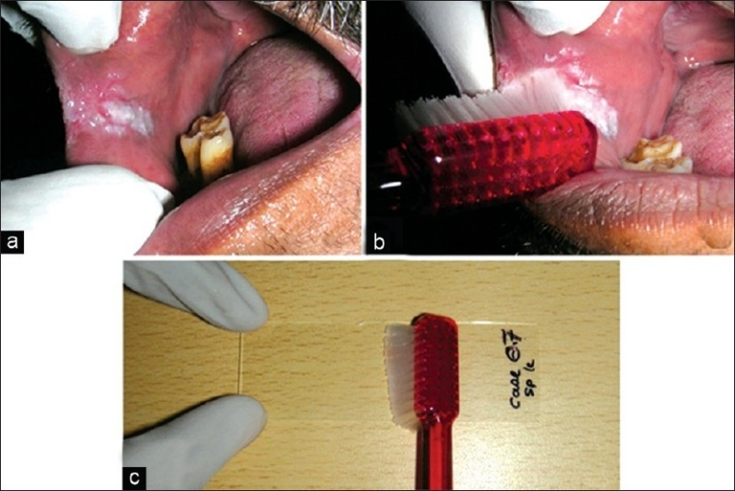
Figure 1
Oral brush biopsy procedure using tooth brush. (a) Speckled leukoplakia in the retro-commissural region; (b) The tooth brush is brushed in one direction over the entire lesion many times until pinpoint bleeding is obtained; (c) The material from the brush is spread on the middle third of a clean, dried glass slide

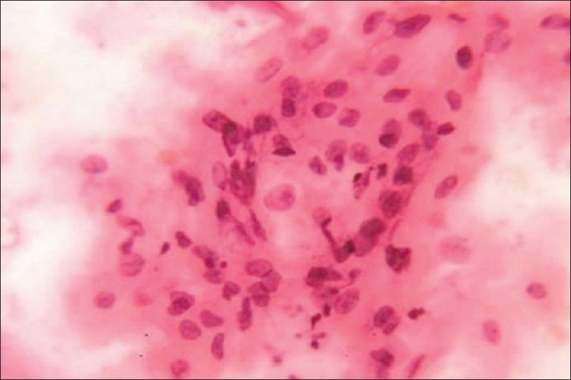
Figure 2
Smear showing sheet of atypical squamous cells with slightly enlarged and hyperchromatic nuclei suggestive of moderate dysplasia (Pap, ×400)

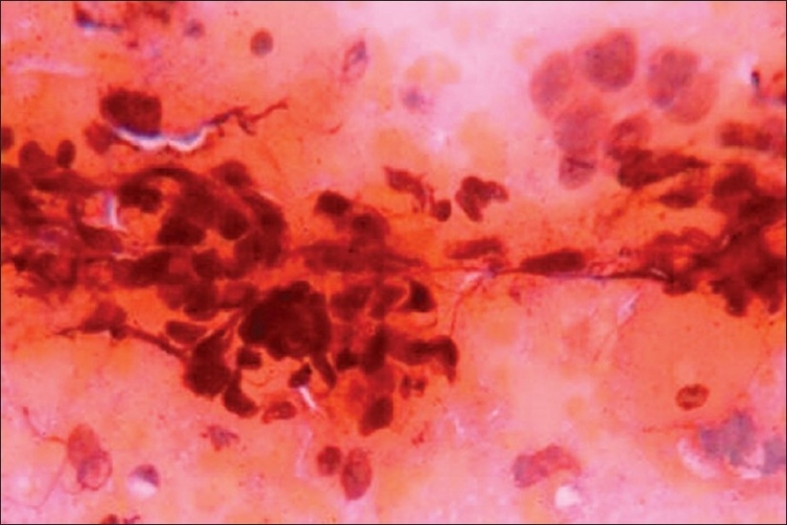
Figure 3
Smear showing loose cohesive clusters of pleomorphic cancer cells with scanty cytoplasm and enlarged nuclei containing numerous nucleoli suggestive of moderately differentiated squamous-cell carcinoma (Pap, ×400)

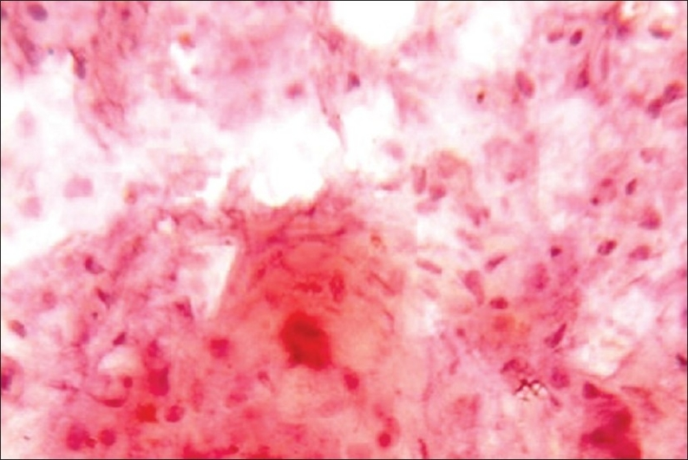
Figure 4
Smear showing abundant fully keratinized ghost cells. Few cells show nuclear enlargement, hyperchromatism and irregular outlines suggestive of verrucous carcinoma (Pap, ×400)

Table 1
Age, sex, affected site and adverse habits in patients of pre-malignant and malignant groups
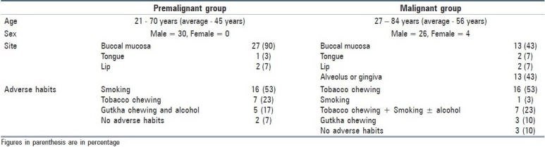

Table 2
Distribution of premalignant and malignant lesions based on histopathology
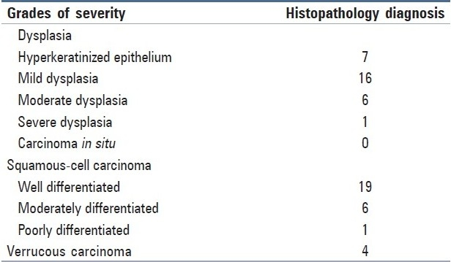

Table 3
Comparison of histopathology and cytopathology groups
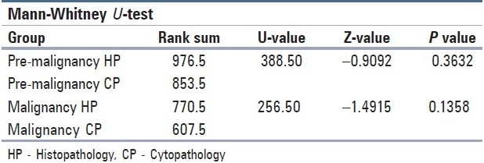

Table 4
Evaluation of cytopathology versus histopathology
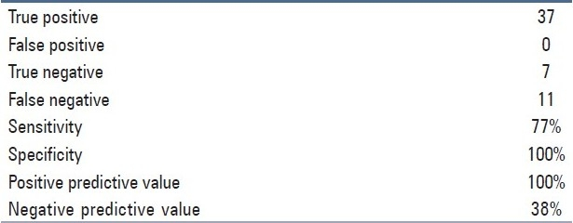

Table 5
Inter-examiner and intra-examiner reliability
